**Name:** Raja Danyal Mushtaq **Email:** rajadanyal.fui@gmail.com

**Hand-on Exercise:** 03 **Batch:** 05 WordPress

**Problem Statement**

**Task A:** You are required to create the following pages on your website (you can use an existing website or create a new one).

1. Contact Us (with contact form having Name, Email, Subject and Message fields).

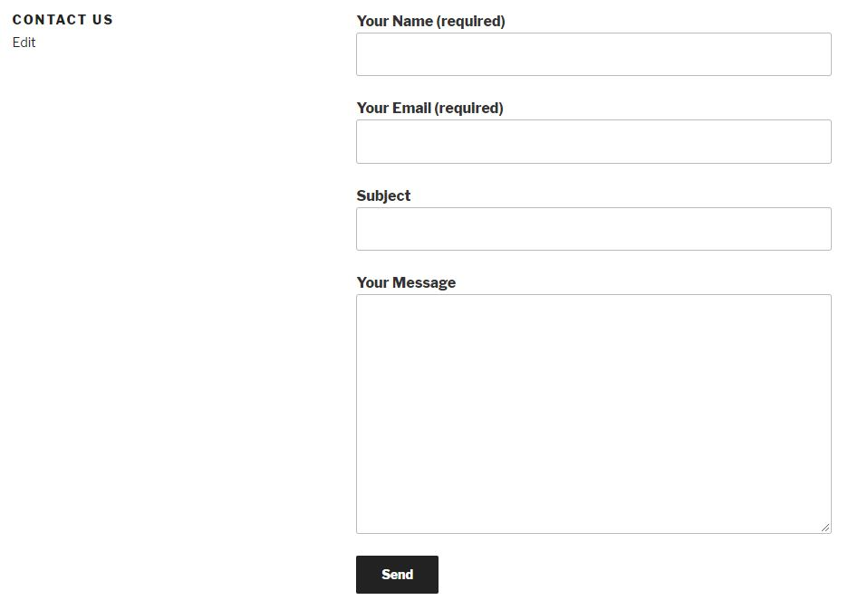

1. About Us (Information about your website).

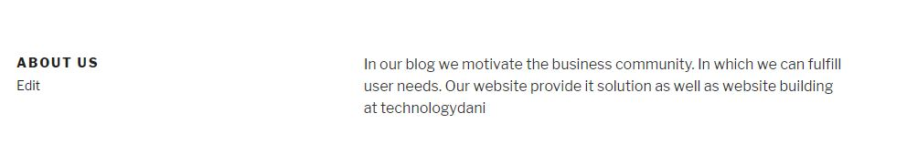

**Task B:** Create sitemap of Pages and Posts of your website using any plugin (i.e. Yoast SEO). (take the screenshot of each sitemap) .

